

AP® Physics C
1985 Free Response Questions

The materials included in these files are intended for use by AP teachers for course and exam preparation in the classroom; permission for any other use must be sought from the Advanced Placement Program®. Teachers may reproduce them, in whole or in part, in limited quantities, for face-to-face teaching purposes but may not mass distribute the materials, electronically or otherwise. These materials and any copies made of them may not be resold, and the copyright notices must be retained as they appear here. This permission does not apply to any third-party copyrights contained herein.

These materials were produced by Educational Testing Service® (ETS®), which develops and administers the examinations of the Advanced Placement
Program for the College Board. The College Board and Educational Testing Service (ETS) are dedicated to the principle of equal opportunity, and their
programs, services, and employment policies are guided by that principle.

The College Board is a national nonprofit membership association dedicated to preparing, inspiring, and connecting students to college and opportunity.
Founded in 1900, the association is composed of more than 4,200 schools, colleges, universities, and other educational organizations. Each year, the
College Board serves over three million students and their parents, 22,000 high schools, and 3,500 colleges, through major programs and services in
college admission, guidance, assessment, financial aid, enrollment, and teaching and learning. Among its best-known programs are the SAT®, the
PSAT/NMSQT®, and the Advanced Placement Program® (AP®). The College Board is committed to the principles of equity and
excellence, and that commitment is embodied in all of its programs, services, activities, and concerns.

APIEL is a trademark owned by the College Entrance Examination Board. PSAT/NMSQT is a registered trademark jointly owned by the College Entrance Examination Board and the National Merit Scholarship Corporation. Educational Testing Service and ETS are registered trademarks of Educational Testing Service.
1985M1. A projectile is launched from the top of a cliff above level ground. At launch the projectile is 35 meters above the base of the cliff and has a velocity of 50 meters per second at an angle 37° with the horizontal. Air resistance is negligible. Consider the following two cases and use g = 10 m/s², sin 37° = 0.60, and cos 37° = 0.80.

Case I: The projectile follows the path shown by the curved line in the following diagram.
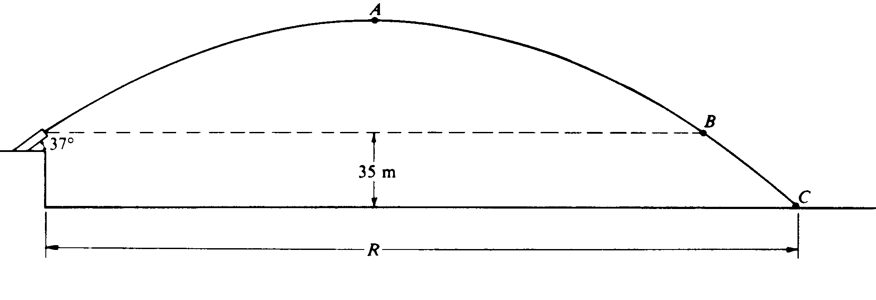
a. Calculate the total time from launch until the projectile hits the ground at point C.
b. Calculate the horizontal distance R that the projectile travels before it hits the ground.
c. Calculate the speed of the projectile at points A, B and C.

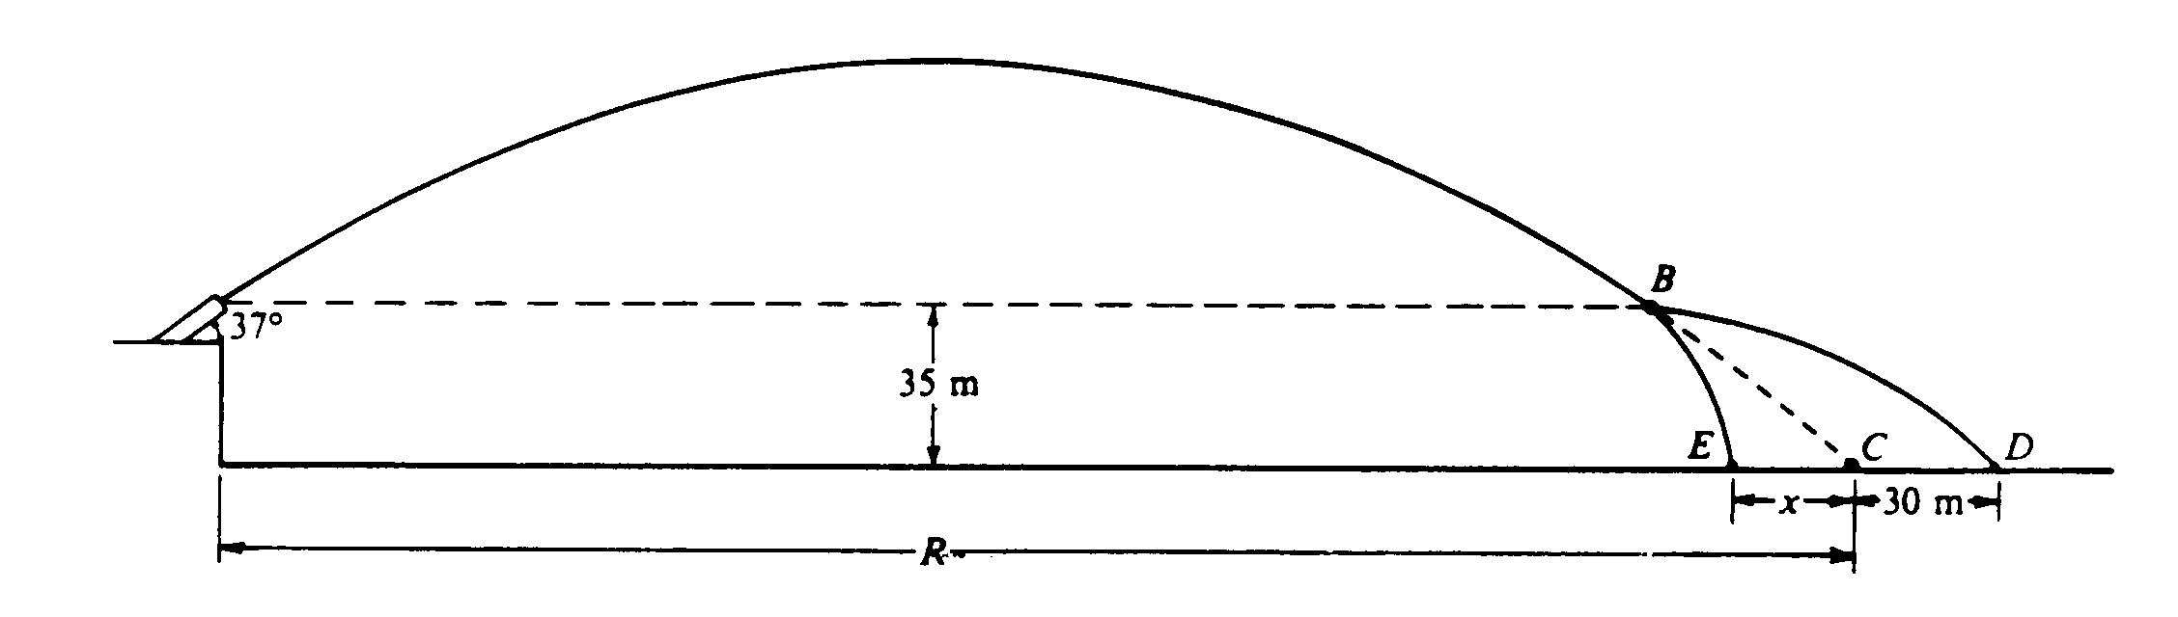
Case II: A small internal charge explodes at point B in the above diagram, causing the projectile to separate into two parts of masses 6 kilograms and 10 kilograms. The explosive force on each part is horizontal and in the plane of the trajectory. The 6-kilogram mass strikes the ground at point D, located 30 meters beyond point C, where the projectile would have landed had it not exploded The 10-kilogram mass strikes the ground at point E.
d. Calculate the distance x from C to E.

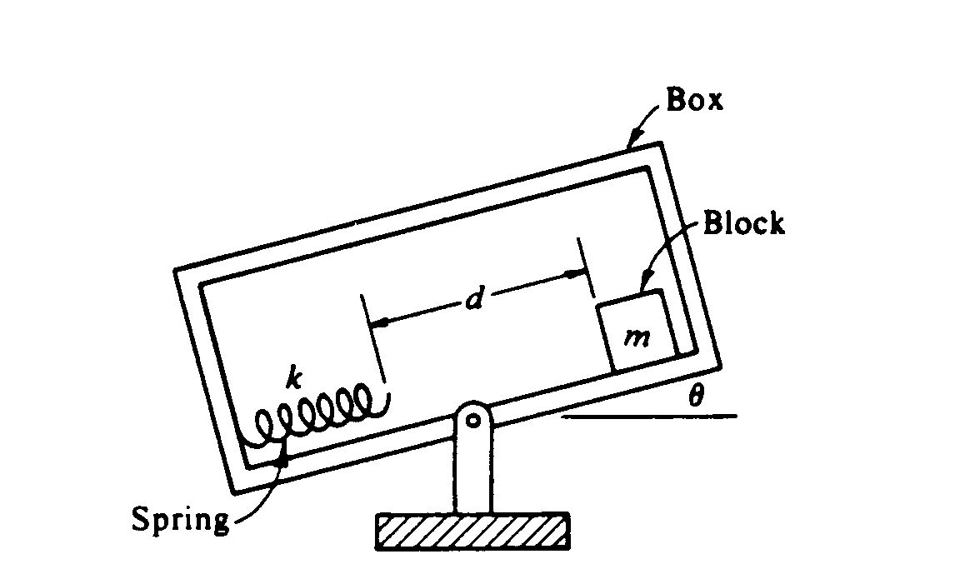
1985M2. An apparatus to determine coefficients of friction is shown above. The box is slowly rotated counterclockwise. When the box makes an angle θ with the horizontal, the block of mass m just starts to slide, and at this instant the box is stopped from rotating. Thus at angle θ, the block slides a distance d, hits the spring of force constant k, and compresses the spring a distance x before coming to rest. In terms of the given quantities, derive an expression for each of the following.
a. μ_{s} the coefficient of static friction.
b. ΔE, the loss in total mechanical energy of the block-spring system from the start of the block down the incline to the moment at which it comes to rest on the compressed spring.
c. μ_{k}, the coefficient of kinetic friction.

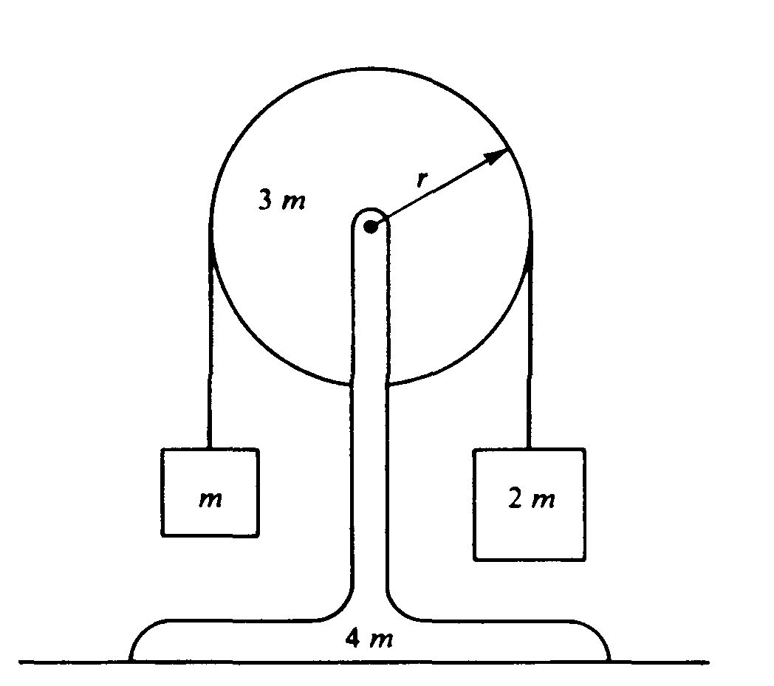
1985M3. A pulley of mass 3m and radius r is mounted on frictionless bearings and supported by a stand of mass 4m at rest on a table as shown above. The moment of inertia of this pulley about its axis is 1.5mr².
Passing over the pulley is a massless cord supporting a block of mass m on the left and a block of mass 2m on the right. The cord does not slip on the pulley, so after the block-pulley system is released from rest, the pulley begins to rotate.
a. On the diagrams below, draw and label all the forces acting on each block.
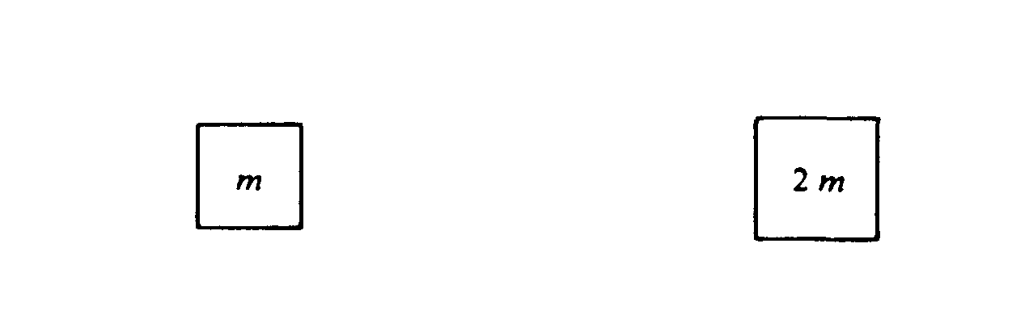
b. Use the symbols identified in part (a) to write each of the following.
i. The equations of translational motion (Newton's second law) for each of the two blocks
ii. The analogous equation for the rotational motion of the pulley
c. Solve the equations in part (b) for the acceleration of the two blocks.
d. Determine the tension in the segment of the cord attached to the block of mass m.
e. Determine the normal force exerted on the apparatus by the table while the blocks are in motion.
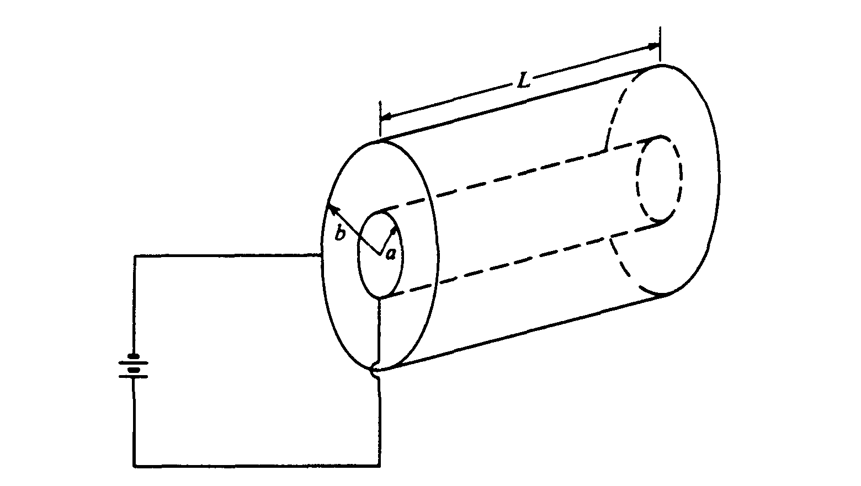
1985E1. A capacitor consisting of conducting coaxial cylinders of radii a and b, respectively, and length L is connected to a source of emf, as shown above. When the capacitor is charged, the inner cylinder has a charge + Q on it. Neglect end effects and assume that the region between the cylinders is filled with air. Express your answers in terms of the given quantities.
a. Use Gauss's law to determine an expression for the electric field at a distance r from the axis of the cylinder where a < r < b.
b. Determine the potential difference between the cylinders.
e. Determine the capacitance C_{o} of the capacitor.

One third of the length of the capacitor is then filled with a dielectric of dielectric constant k = 2, as shown in the following diagram.
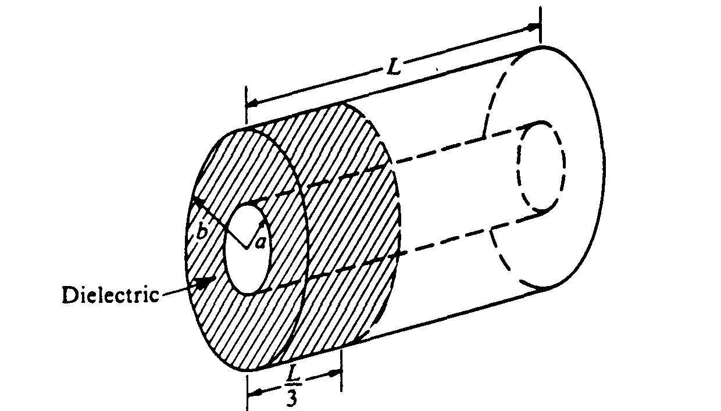
d. Determine the new capacitance C in terms of C_{o}.
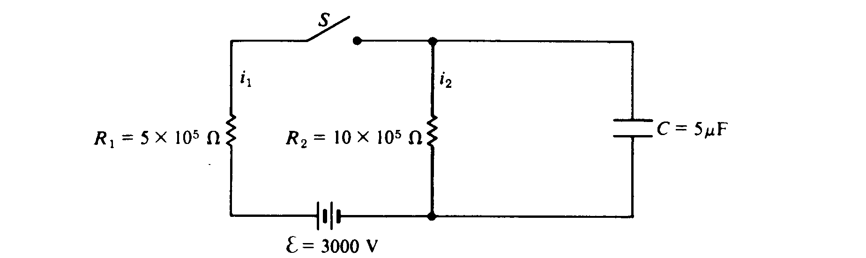

1985E2. In the circuit shown above, i₁ and i₂ are the currents through resistors R_{l} and R₂, respectively. V₁, V₂, and V_{c} are the potential differences across resistor R₁ resistor R₂, and capacitor C, respectively. Initially the capacitor is uncharged.
a. Calculate the current i₁ immediately after switch S is closed.
b. On the axes below, sketch the potential difference V₂ as a function of time t.
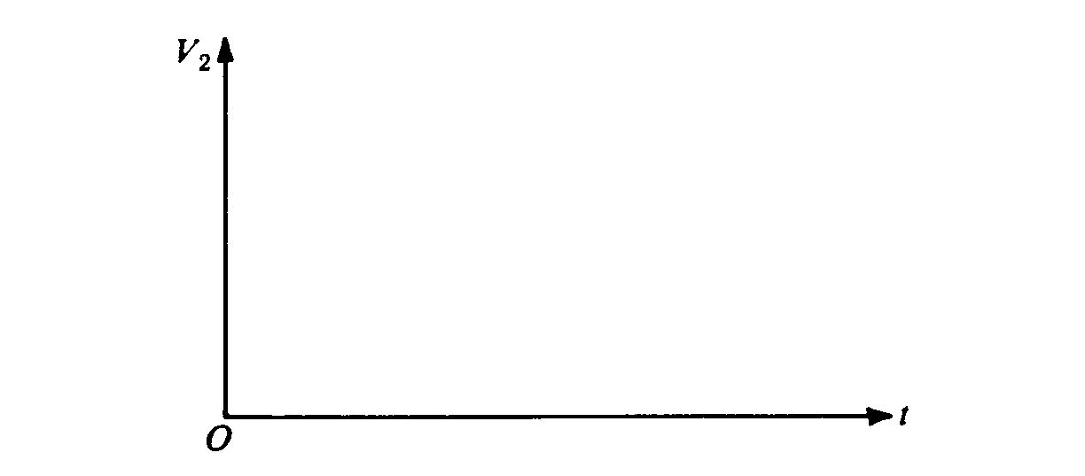
Assume switch S has been closed for a long time.
c. Calculate the current i2.
d. Calculate the charge Q on the capacitor.
e. Calculate the energy U stored in the capacitor.

Now the switch S is opened.
f. On the axes below, sketch the current i₂ as a function of time t and clearly indicate initial and final
values.
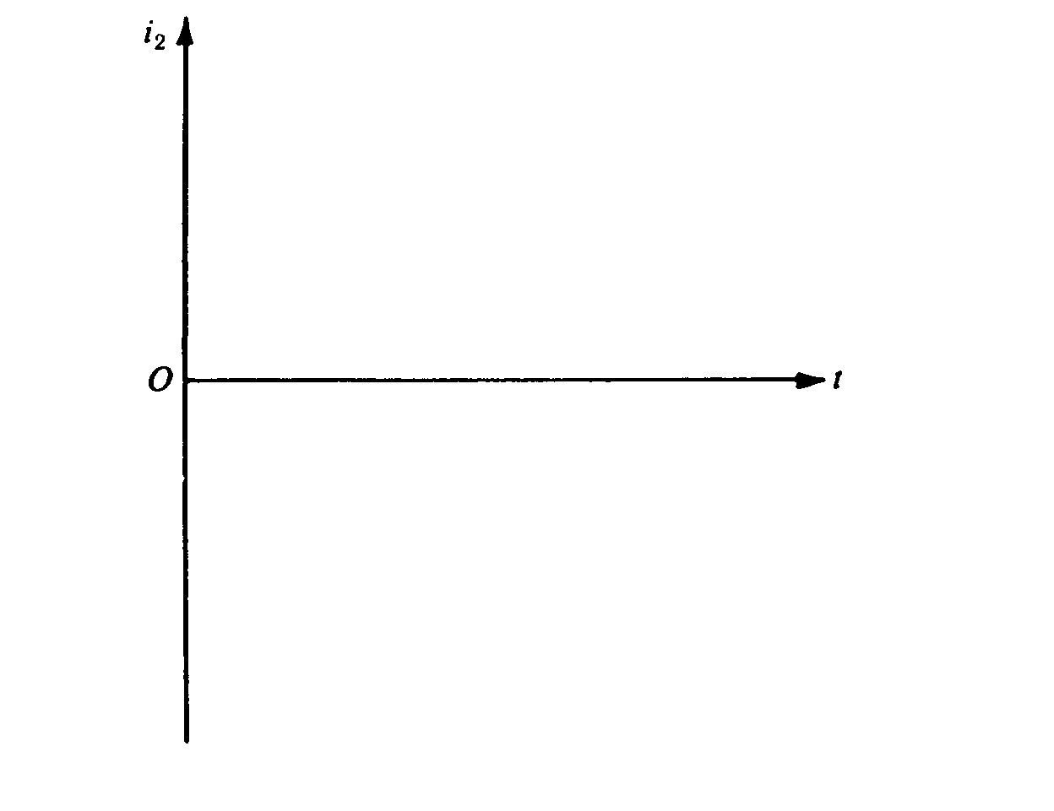
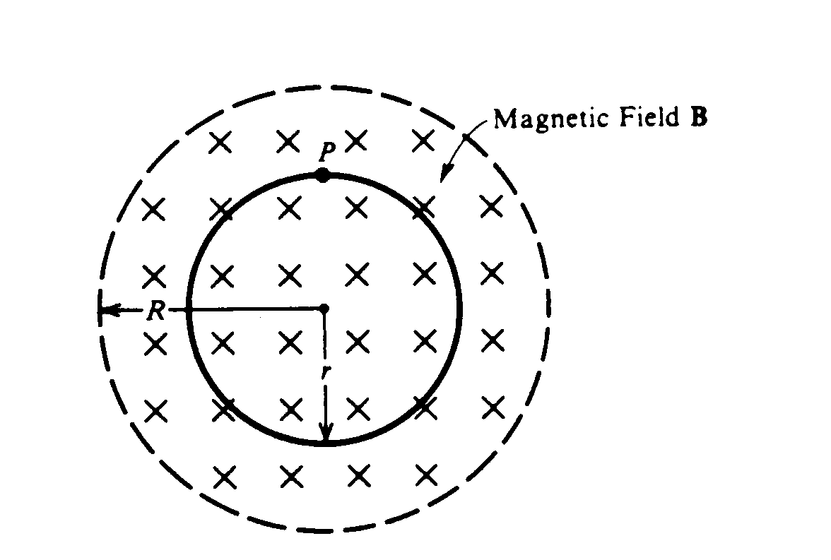
1985E3. A spatially uniform magnetic field B. perpendicular to the plane of the page, exists in a circular region of radius R = 0.75 meter as shown above. A single wire loop of radius r = 0.5 meter is placed concentrically in the magnetic field and in the plane of the page. The magnetic field increases into the page at a constant rate of 60 teslas per second.
a. Determine the induced emf in the loop.
b. Determine the magnitude and direction of the induced electric field at point P and indicate its direction on the diagram above.

The wire loop is replaced by an evacuated doughnut-shaped glass tube, within which a single electron orbits at a constant radius r = 0.5 meter when the spatially uniform magnetic field is constant at 10⁻⁴ tesla.
c. Determine the speed of the electron in this orbit.
d. The magnetic field is now made to increase at a constant rate of 60 teslas per second as in parts (a) and (b) above. Determine the tangential acceleration of the electron at the instant the field begins to increase.

